Sticky Tape Activity

Part I – Top tapes

1. Take a 15 cm to 20 cm piece of transparent tape and make a handle on the end by folding under the first cm of tape, sticky side to sticky side. Place this tape on the lab table. This is the base tape.

2. Attach a second similarly prepared strip of tape onto the base tape. Label this tape “T” for top.

3. Repeat steps 1 and 2 so that you have two sets of base and top tapes.

4. Quickly peel the first of the T tapes from the base, and hang the T tape from the edge of the table.

5. Quickly peel the second of the T tapes from the base and slowly bring the second T tape near the hanging T tape. Describe what you see. Include a series of sketches of the tapes as they approach one another with vectors to represent the forces on the tapes. Label the forces.

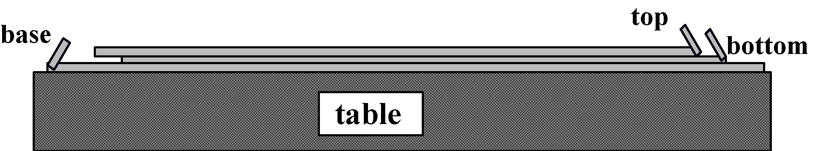

Part 2 – Top and Bottom tapes

6. Repeat steps 1 through 3 above, but do not label the tapes yet. Place another
15 cm tape with handle on top of each of the tape sets. You now have two sets of 3-layer tapes.

7. Label uppermost tape “T” for top, and the middle tape “B” for bottom.

8. Cut 2 pieces of paper, the same dimensions as the tapes, and hang one from the edge of the table. Label the hanging paper “P." Approach the hanging paper with the other piece of paper. Describe what you see.

9. Cut 2 pieces of aluminum foil, the same dimensions as the tapes, and hang one from the edge of the table. Label the hanging foil “F." Approach the hanging foil with the other piece of foil. Describe what you see.

10. Gently peel one set of T and B tapes from its base tape, keeping the T and B tapes together. Rub the tape on a faucet or your lip until there is no attraction to your hand. Quickly peel them apart.
11. Hang each strip next to the hanging paper and foil. (Place them at least 15 cm apart.)
table

B

T

P

F

Not to scale

12. Repeat step 10 with the other set of tapes.

13. With a T tape hanging from one hand and a B tape hanging from the other, experiment by approaching each of the four strips hanging on your table (top tape, bottom tape, foil and paper). Describe what you see. Include a series of sketches of the tapes as they approach one another with vectors to represent the forces on the tapes. Label the forces.

